EX 1
- )ERD MCQ - CodeChef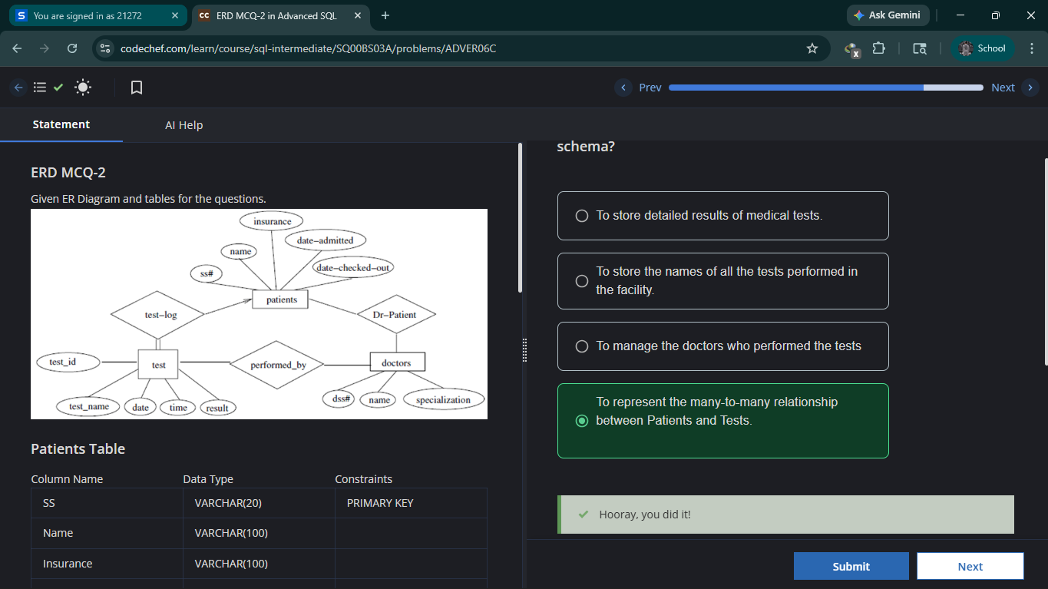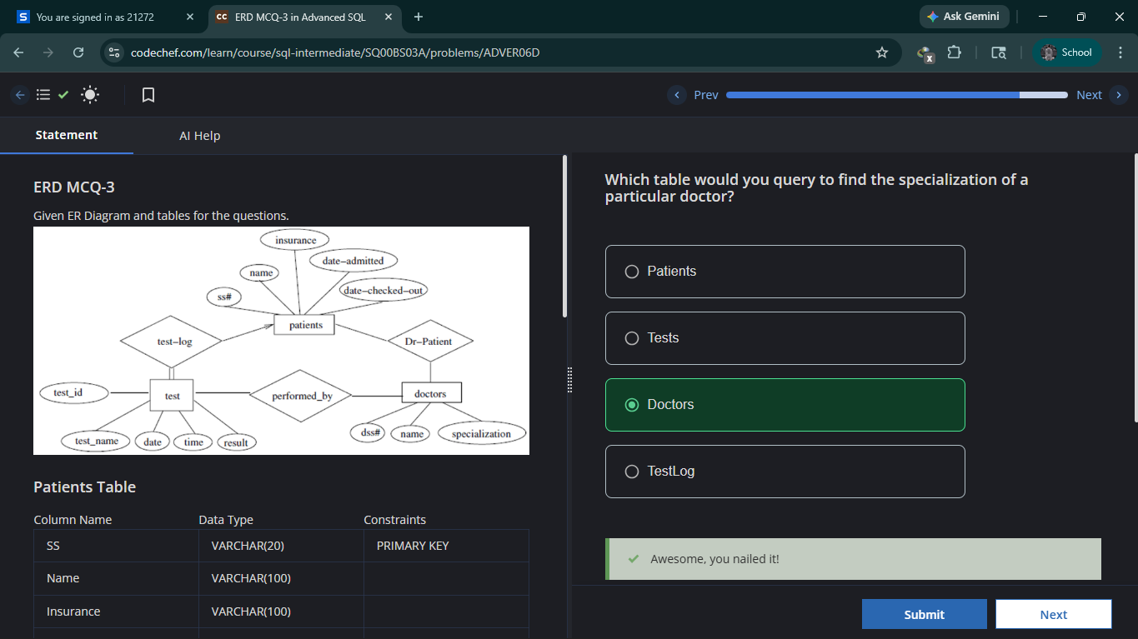
- 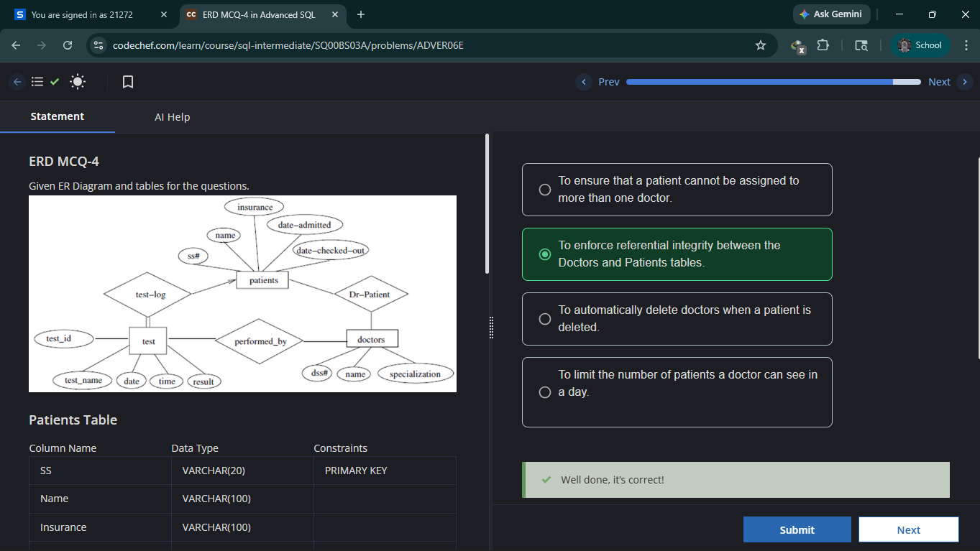

EX:2

Practice - Create Table with Constraints - CodeChef

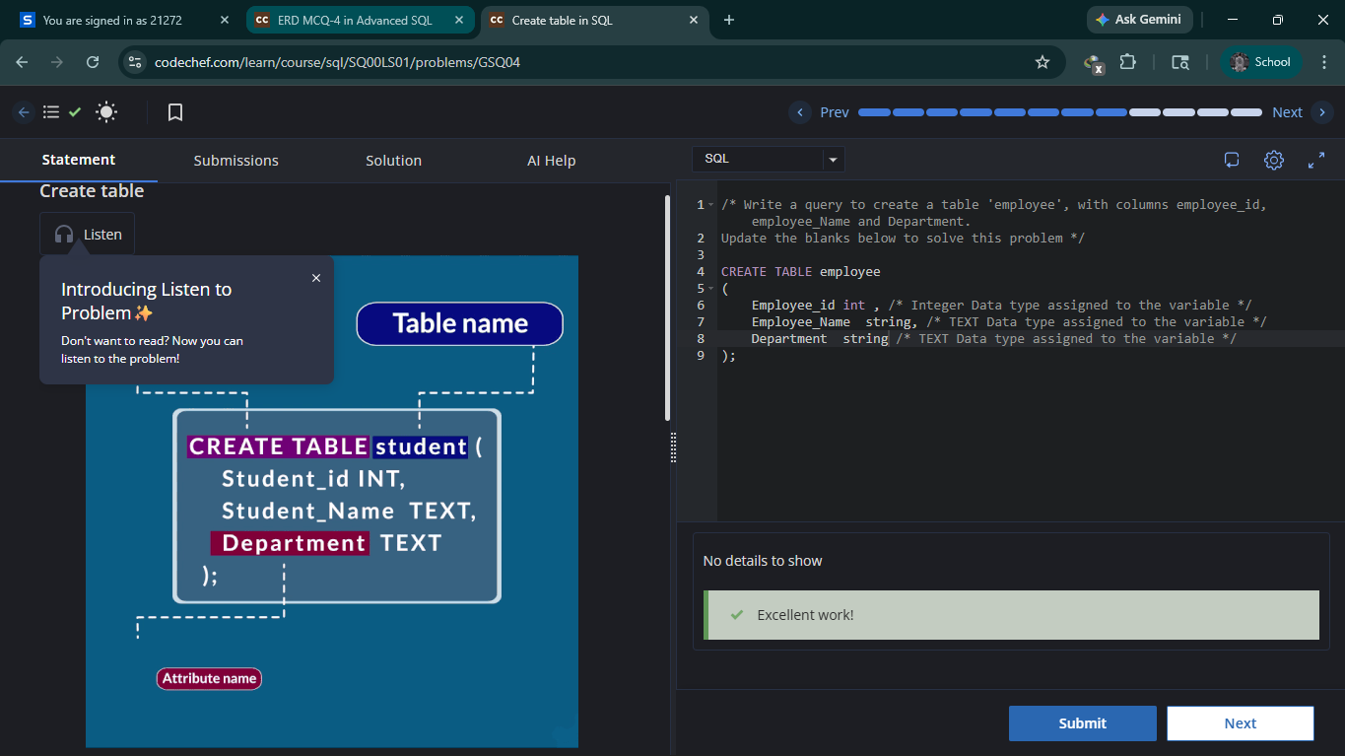

Practice Problem - Alter table-CodeChef

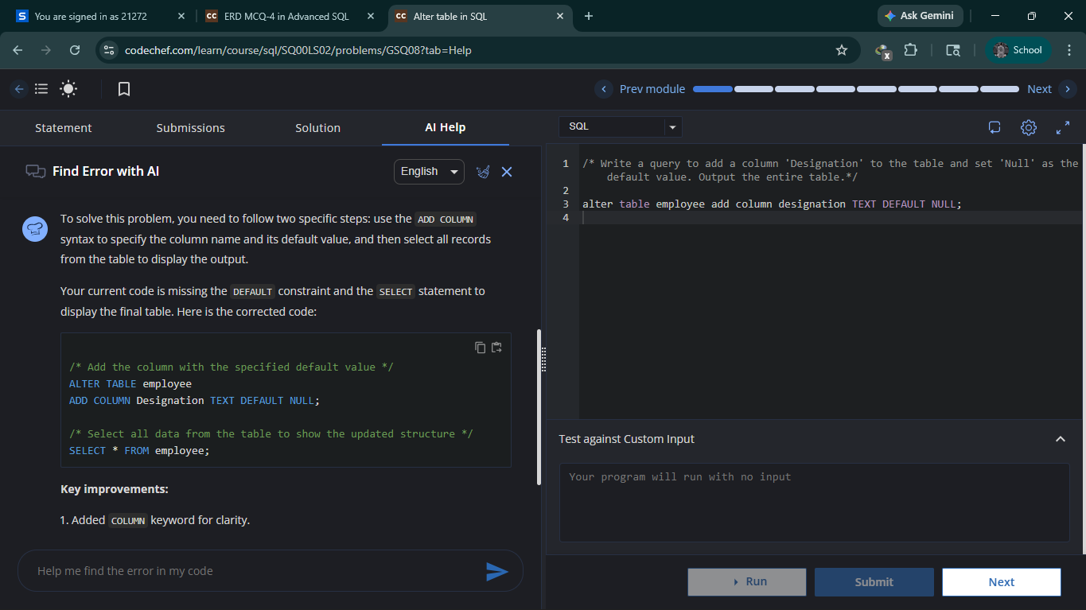

- Delete Duplicate Emails - Leetcode

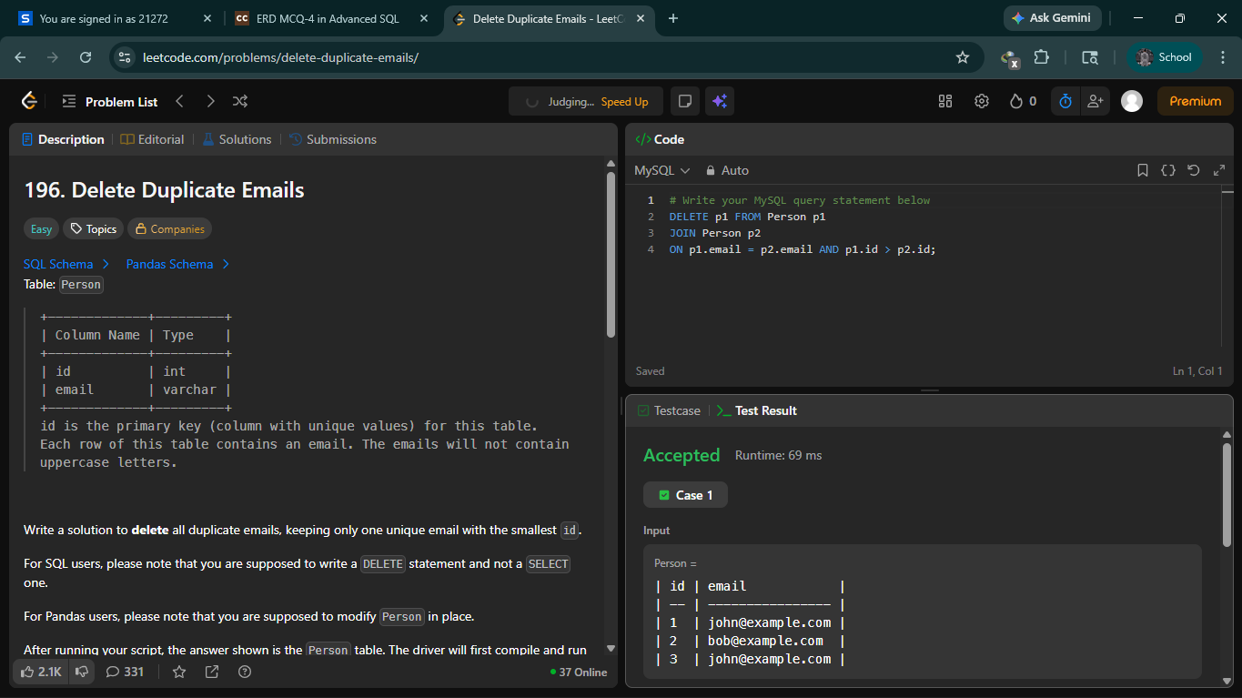

EX:3

- Tree node – Leet Code

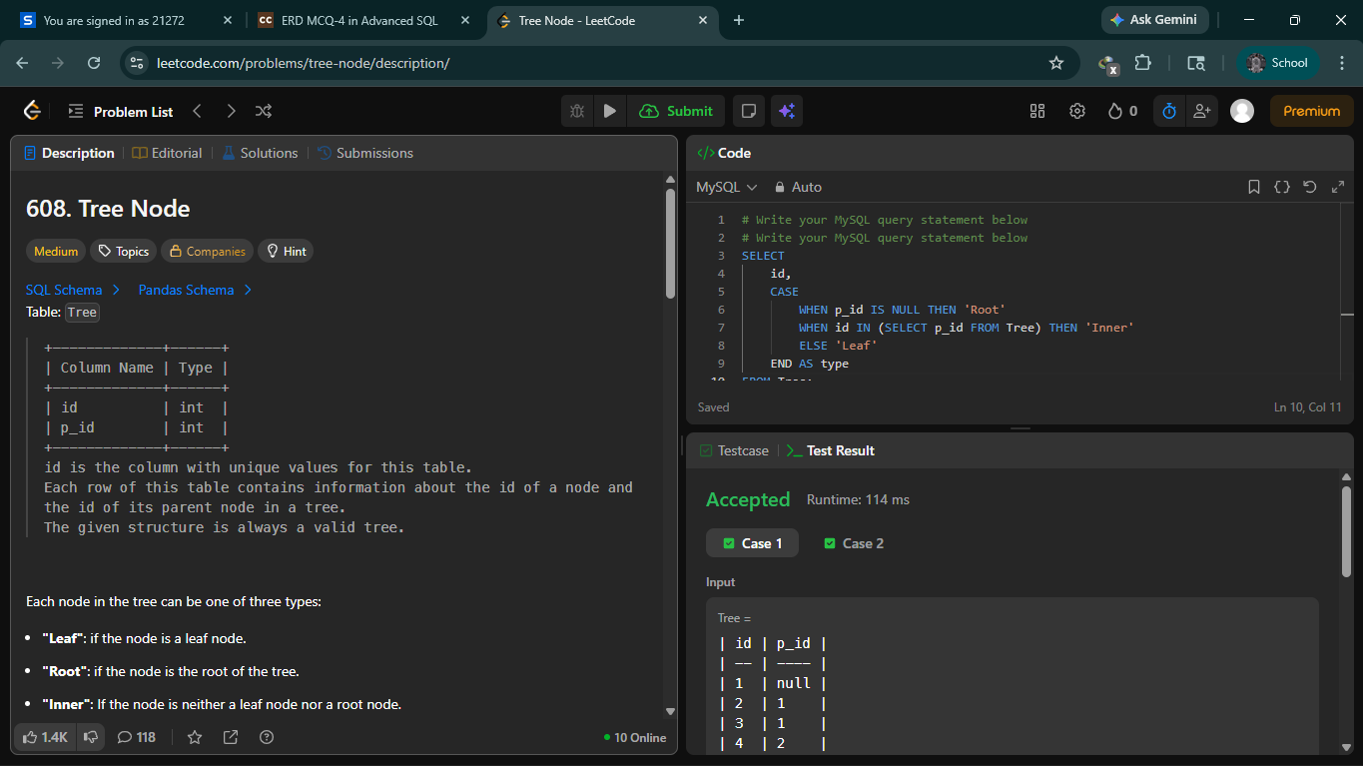

Contest Leaderboard - Hacker Rank

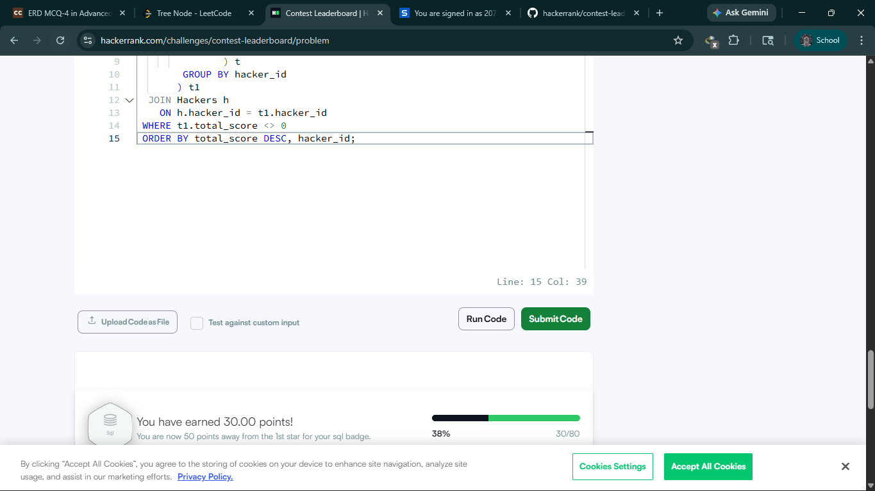

The PADS – Hacker Rank

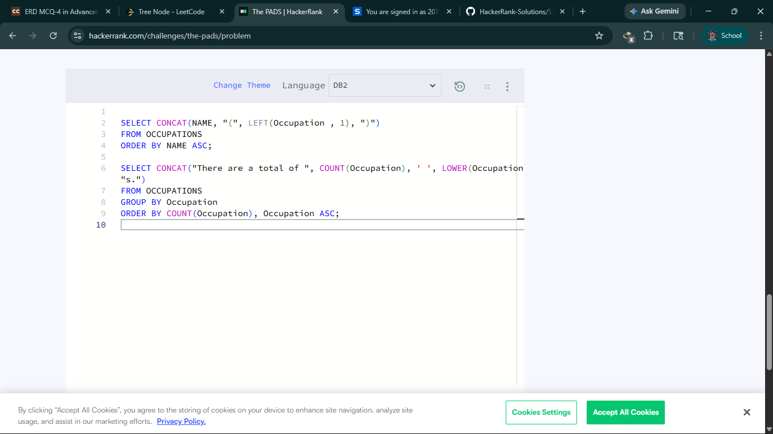

EX:4
184. Department Highest Salary -Leetcode

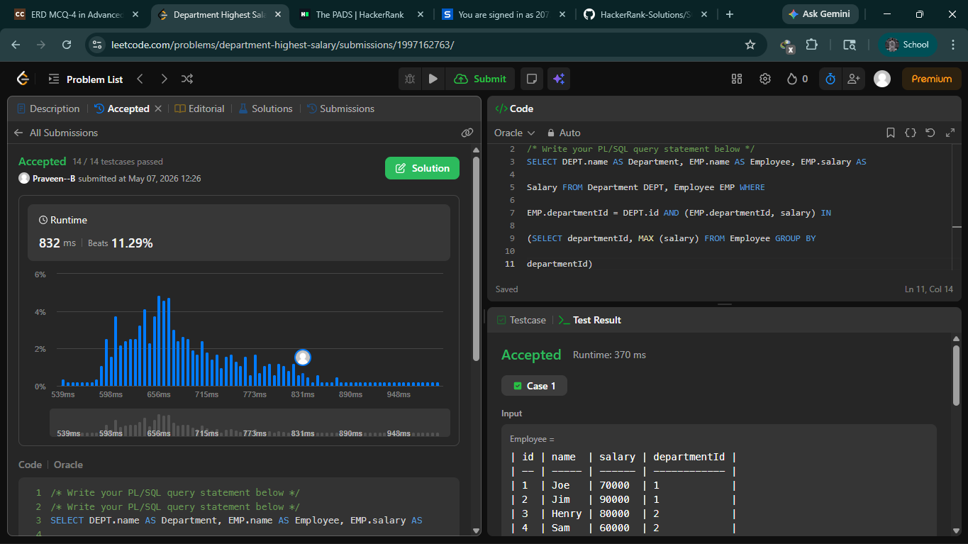

Problem 185: Department Top Three Salaries - Leetcode

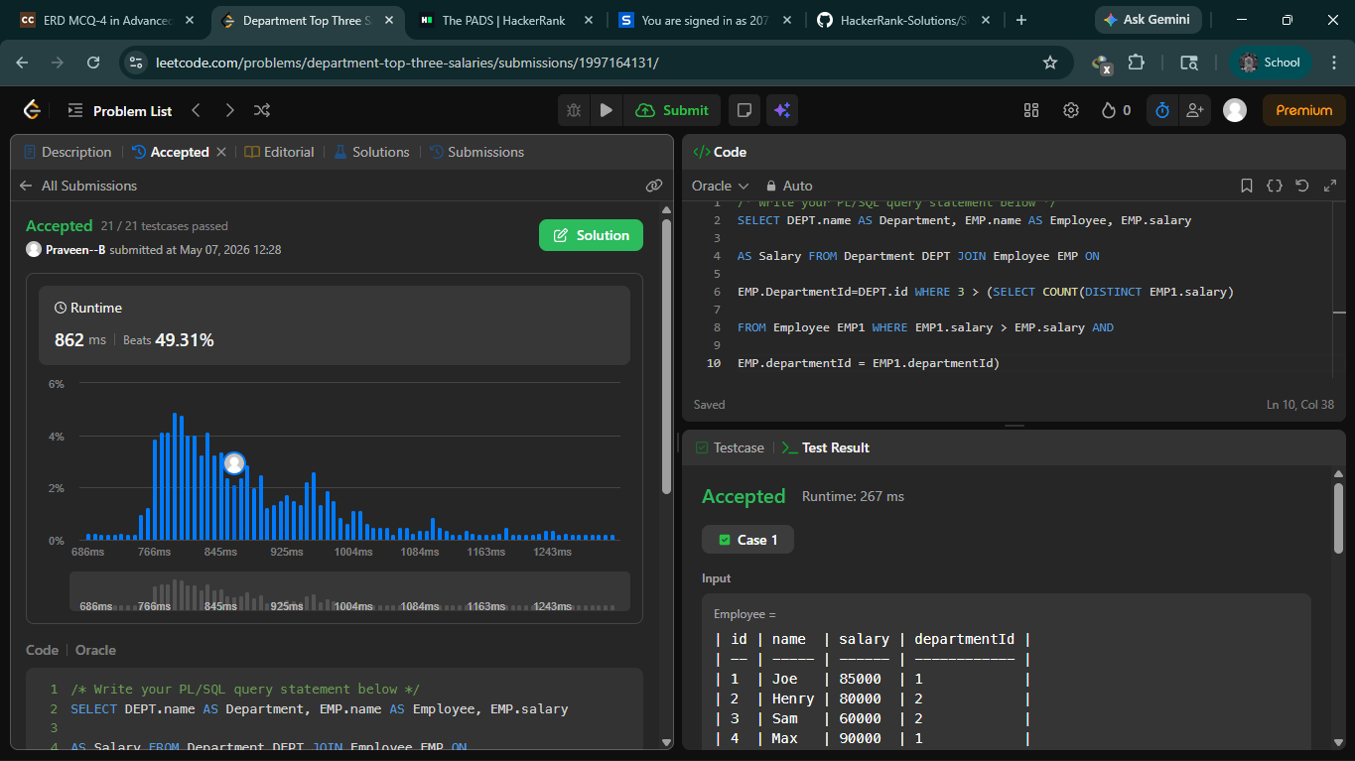

EX:5

175 – combine two tables

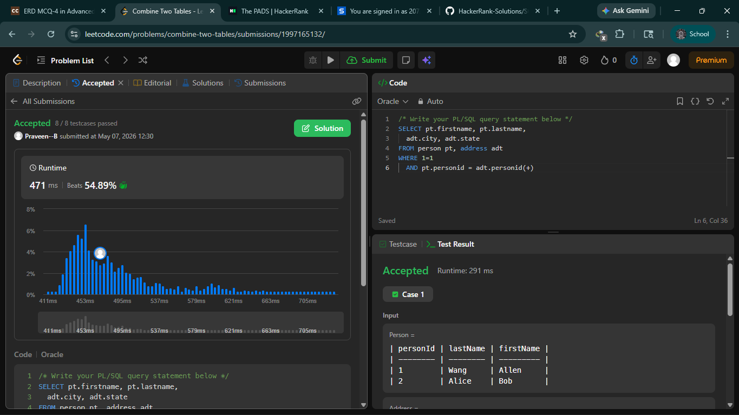

180 – Consecutive numbers

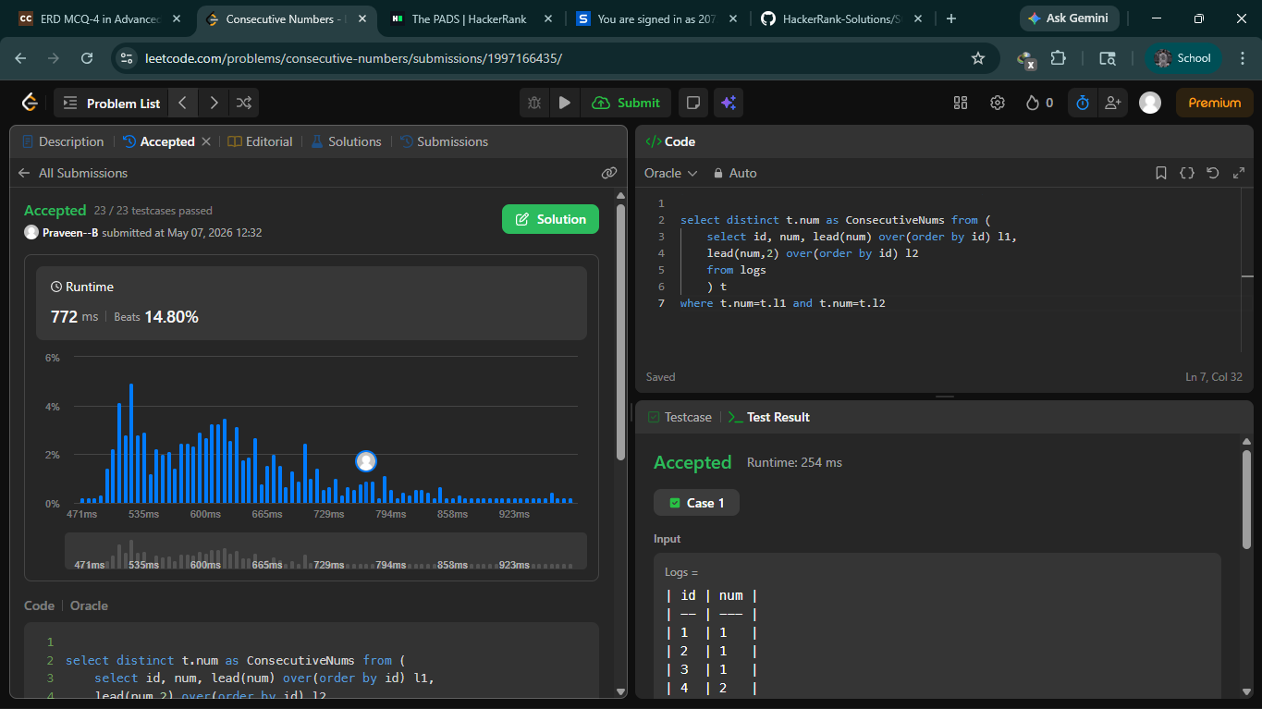

185 – Department Top Three Salaries

